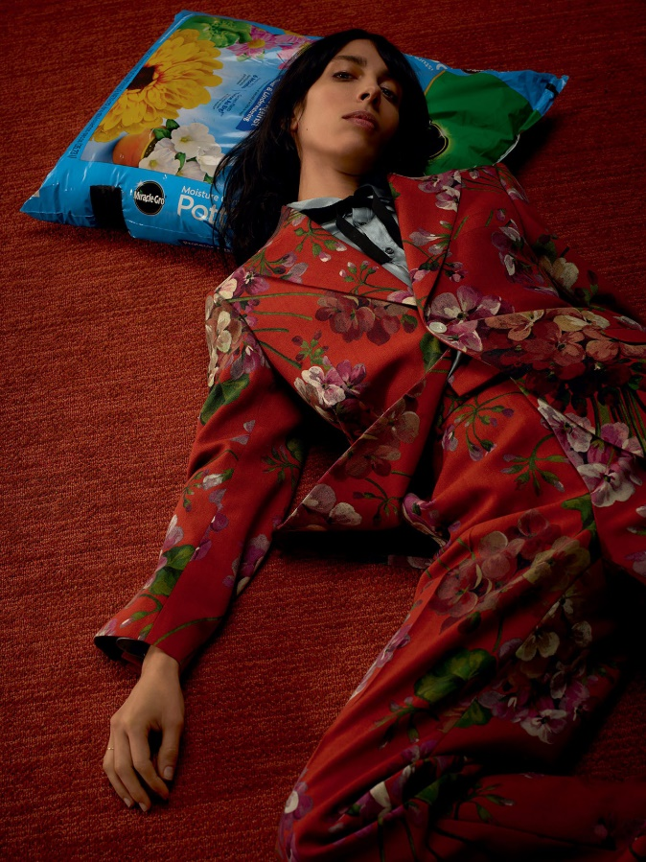
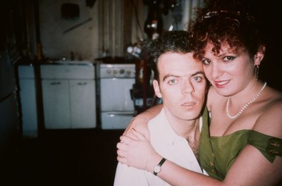
Contextual studies task 4 Inside Out
Roe Ethridge
This image is interesting because Ethridge (the photographer) plays on the idea of bringing outside elements in. The model is placed with her head on a bag of compost, lying on a typically interior surface. What’s interesting about this image by Ethridge, is the link between the bag of compost and the Gucci garments the model is wearing. The piece of clothing links both compost element and the interior elements together. The rich tone of red is both displayed on the carpet and the models clothing, therefore creating a link between the elements. The bag of compost links cleverly to the floral pattern on the model’s outfit. As an audience we are looking inside but still referring to the outside.
Nan Goldin
This iconic picture of Goldin and her boyfriend at the time, features in her book from 1986, ‘from the ballad of sexual dependency’ This image plays on the idea that the inside is used as an intermate space. This photograph is interesting because photographers are often the ones on the outside of a photograph looking in. However, this image by Goldin is different because Goldin has put herself inside the photograph. By putting herself inside her own image gives the photograph a more personal feel. The interior space is associated with privacy, the juxtaposition of the outside space which is open to the public. As the audience we are the ones who feel like an outsider being allowed access into Goldin’s space.

The boundaries between ‘Inside’ and ‘Outside’
‘Inside’ and ‘Outside’ are a division not only in society, but from a photographer’s point of view also. The quotation “outside and inside form a dialectic of a division” is a famous quote from Gaston Bacherlard, which supports my point made about the division Photographers have been experimenting with for years. As photographers we are often on the outside of a situation looking in, therefore only getting an outsider’s perspective on a situation. Some photographers such as Nan Goldin, have played with this idea. Goldin put herself inside of her own photographs and formed close relationships between the groups of people she was photographing at the time, therefore getting a totally different perspective on a situation. ‘Inside’ spaces are viewed as private “traces of the inhabitant are imprinted in the interior” as Walter Benjamin said. ‘Inside’ spaces are made by the person whom inhabits them. We can change and alter our own ‘inside’ space into our very own phantasmagorias spaces. ‘Outside’ can mean several different things; an outcast in society or nature. We as photographer put ourselves outside a situation to get a different perspective to those who are inside the situation.

