Contextual studies task 1 – Grace Bontoft
Simon Norfolk from series Full Spectrum Dominance: missiles, rockets, satellites in America, 2008
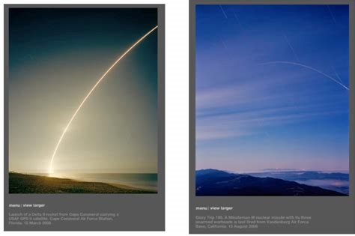
Deborah Wills “photography shows beauty in different ways”
This quote by Deborah Wills I believe is very relevant to these images by Simon Norkfolk. The photographs show missiles and rockets being tested over a majestic landscape, somewhere in America. Should these images be considered as war or beauty? Even though the missiles are being tested for military purposes, the rolling hills and soft lighting make the rocket seem more like a shooting star rather than a threat to life. Is this image a proof that the American military were testing missiles? or on the other hand is this image a well-timed picture whose sole purpose is to please audiences? Personally, I like these photos because they raise a lot of questions amongst audiences. My favourite aspect of these pieces by Norkfolk, is whether these images are to be considered a documentation of an historic event, or are the photographs just a simple landscape, with the missiles in the background giving the images a more surreal effect to them. What was the photographer’s purpose when he took these images? Was his purpose to create a landscape picture or to document and prove the missiles were being fired? I believe the most prominent questions is, did Norkfolk create these images with the intent to show beauty in a landscape, or show the effects of war.
Keywords
- Proof or picture
- Landscape
- Documentation
- War
- beauty
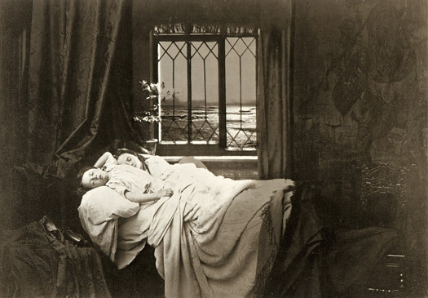

Henry Peach Robinson, ‘Sleep’, 1867
Keywords
- Production
- Old
- Icon
- Picture
- Time
‘Un-named police photographer, photograph of individual charged with driving under the influence, resisting arrest, and driving with an expired licenses, 2014’
Keywords
- Genre
- Proof
- Mug shot
- Portrait
- Public

